First formative assessment
Directions- Choose the correct natural disaster that could cause the damage.
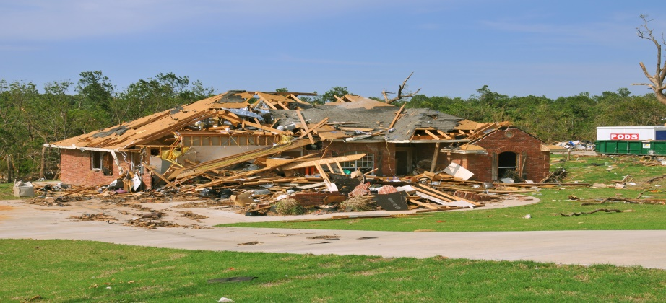
A. Tornado B. Tsunami C. Volcano
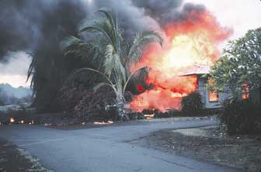
A. Tornado B. Earthquake C. Volcano
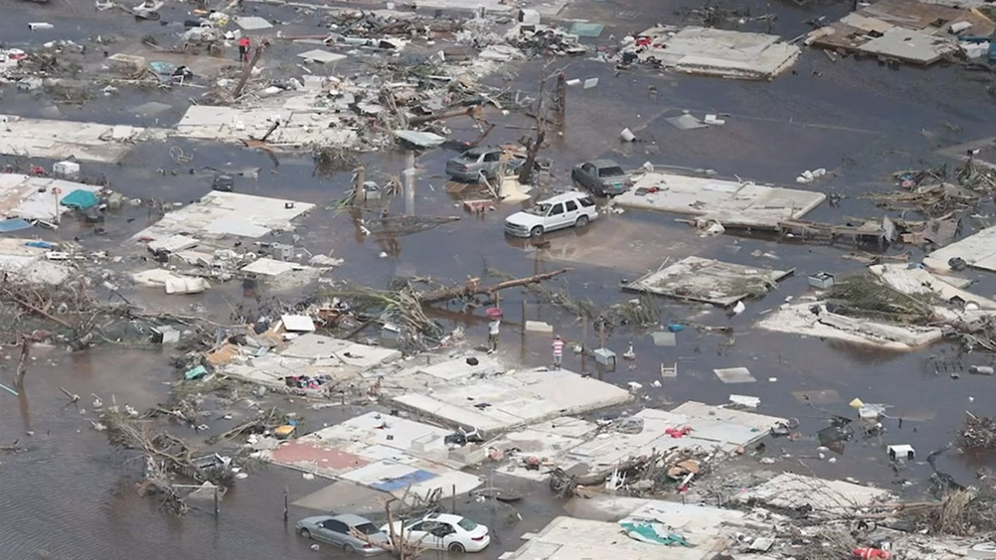

A. Hurricane B. Volcano C. Earthquake

PowerPoint for engagement stage. The teacher used this to ask the question “Could you survive this, if so how?”
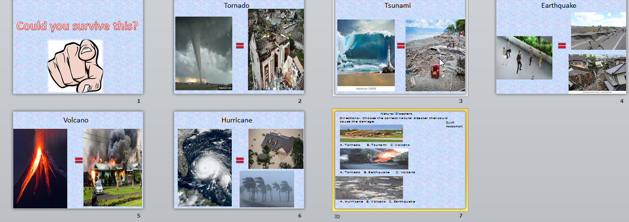

Activity 1 of exploration phase
Students watched natural disaster simulators and had to write what they thought was going to happen, what happened, and if their prediction was correct. The activity was design to help students explore what it is like when a certain disaster occurs.

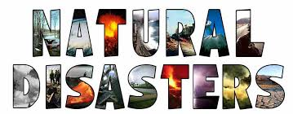

Name:________________________________________________ Date:_____________________________
Directions- Predict what will happen in the video. Share with the group. Then watch the video. After the video write what actually happened in the video. Was your prediction correct? What surprised you? Share with the group.
Natural Disaster (Station) | Prediction (I think…..) | What happened?  (In the video…..) | Was your prediction correct?  What surprised you?
Activity 2 of exploration phase
Students researched facts about a natural disaster and had to write it on this paper. The students also had to write how they could prepare/survive the natural disaster. This paper is to help students organize their thoughts.

Activity 2

Directions- Pick one natural disaster from the list. Go to Kiddle.co. Research 3 facts about the natural disaster and write them on this paper. Research facts about how to survive the natural disaster and write them on this paper.
3 Facts about ____________________________________
Fact 1

Fact 2

Fact 3

How to Survive a _______________________________________
____________________________________________________________________________________________________________________________________________________________________________________________________
Assessment 2
Assessment 2 was used during the exploration stage. The assessment helped the teacher know which student understood the differences in the natural disasters.

Name:____________________________ Date:___________
Directions: Read the following sentences; determine what natural disaster the person is experiencing.
Tornado | Hurricane | Tsunami | Earthquake | Flood
1. The lights went off at John’s house. He looked outside and saw the wind blowing really hard. Then he saw a cone shaped structure plow through his neighbor’s yard, destroying everything. John experienced a _____________.
2. Marlo was walking home and all of a sudden the ground started to shake. Marlo experienced a ______________.
3. Leslie was playing basketball when she noticed a lot of water on the curb. She looked down the street and realized that the street and cars were underwater. Leslie experienced a _________________.
4. Jesse was fishing when a huge giant wave that was 20 feet in the air rushed on him. Jesse experienced a ______________.

Powerpoint for explanation phase
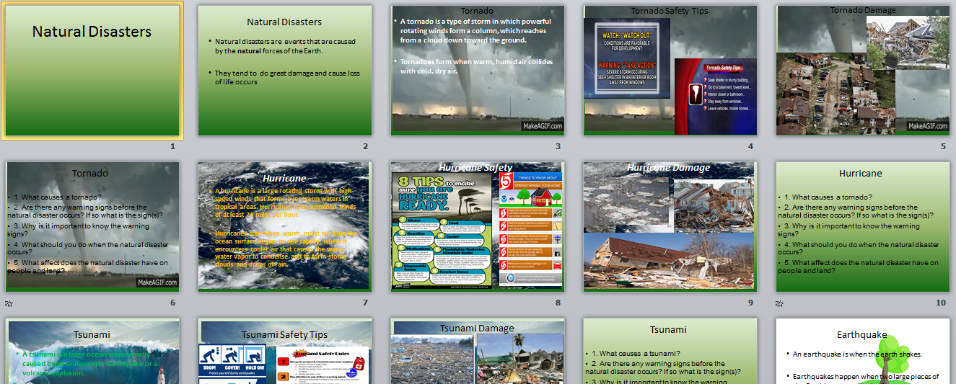
The Powerpoint was used to help students fully understand each natural disaster and safety tips for surviving the natural disasters. The teacher went through each slide and explained each disaster. There is an assessment on the last slide that helped the teacher determine which student knew facts about a certain disaster.

